shStep 1: Install the Failover Cluster role

[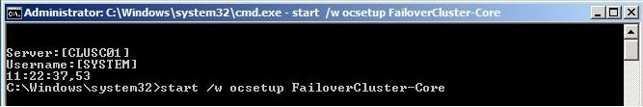](http://blogs.technet.com/blogfiles/aralves/WindowsLiveWriter/BuildingaFailoverClusterwithServerCorePa_EB28/failovercluster-1_2.jpg)

Make sure you do this on both Server Core machines

Step 2: Configure and Start the iSCSI initiator service

[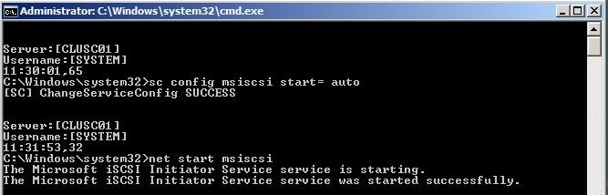](http://blogs.technet.com/blogfiles/aralves/WindowsLiveWriter/BuildingaFailoverClusterwithServerCorePa_EB28/failovercluster-2_2.jpg)

Again perform this on both machines. Now the Microsoft iSCSI initiator service is configured and will start up during boot time.

Step 3: Connecting the Server Core boxes to the iSCSI storage box

Here are all steps you should take on both Server Core boxes to connect to the storage.

1. iSCSIcli QAddTargetPortal <Storage Box, Portal IP Address>   
   Required to refresh the new target built,
2. iSCSIcli ListTargets   
   You should see the iQN of the target created   
     
   [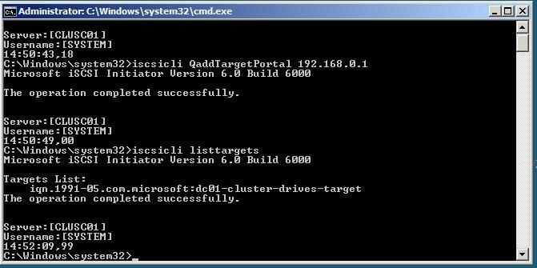](http://blogs.technet.com/blogfiles/aralves/WindowsLiveWriter/BuildingaFailoverClusterwithServerCorePa_EB28/failovercluster-3_2.jpg)
3. iSCSIcli QloginTarget <Target IQN>   
   You should see a connection and session id
4. iSCSIcli PersistentLoginTarget <target_iqn> T * * * * * * * * * * * * * * * 0   
     
   NOTE: There are 15 “space” + “*”   
   You do this so you can survive a reboot
5. iSCSIcli ListPersistentTargets   
   You should see a target   
     
   [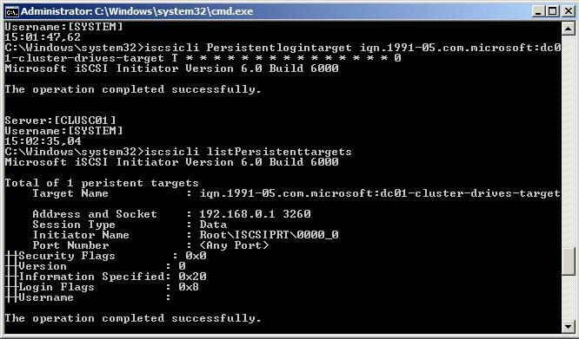](http://blogs.technet.com/blogfiles/aralves/WindowsLiveWriter/BuildingaFailoverClusterwithServerCorePa_EB28/failovercluster-4_2.jpg)
6. iSCSIcli ReportTargetMappings   
     
   You should see the target and a LUN x mapping for every LUN defined in the target

At this stage you have assigned both disks to the server core machines the next step will be to configure the disks

Step 4: Configuring the clustered disks

By being GUI less you need to do this onto the command line.

First list the disks in your boxes by using the diskpart commandline tool:

**diskpart**

list disk (this will return the disks available in your system in my case I had disk 0, 1 and 2 with 0 being my OS disk and the other two the disks for my cluster)

**select disk 1   
attribute disk clear readonly   
online disk   
create part primary   
select part 1   
assign letter=Q**  
**select disk 2   
attribute disk clear readonly   
online disk   
create part primary   
select part 1   
assign letter=S**

**exit**

[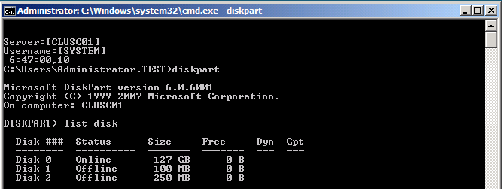](http://blogs.technet.com/blogfiles/aralves/WindowsLiveWriter/BuildingaFailoverClusterwithServerCorePa_EB28/image_4.png)

Format each disk by typing format x: /q where X is your drive letter and don't provide any label name.

The servers are now completely configured to form a Windows Failover Cluster, this process will be explained in Part III of this post.

Step 1: Open Failover Cluster Management Console and Validate the configuration

In my case I will open up the mmc from my Domain Controller but with the RSAT tools you can now also remotely manage failover clusters from an Windows Vista SP1 box.

[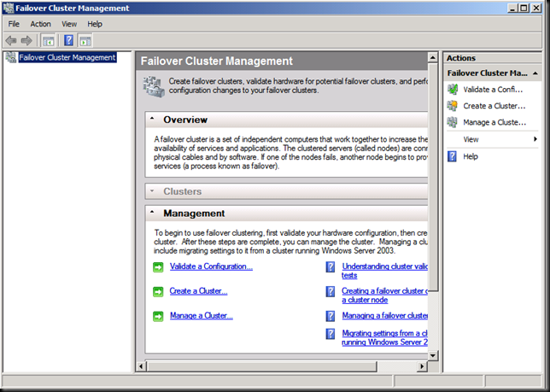](http://blogs.technet.com/blogfiles/aralves/WindowsLiveWriter/BuildingaFailoverClusterwithServerCorePa_DE86/image_2.png)

The first action that needs to be performed prior building the cluster is running the validation tool. This is not needed for a test environment but if you want to get support from Microsoft you need to run this and keep the report, you also need to run the validation tool each time you make changes to the cluster infrastructure, changes like adding an HBA requires a new validation report.   
  
The Validation tool will run tests to determine whether your system, storage, and network configuration is suitable for a cluster. These tests include specific simulations of cluster actions, and fall into the following categories: System Configuration tests, Network tests and Storage tests.

Click on **"Validate a Configuration"** in the action pane.

[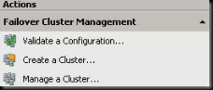](http://blogs.technet.com/blogfiles/aralves/WindowsLiveWriter/BuildingaFailoverClusterwithServerCorePa_DE86/image_8.png)  
  
Add both nodes to be validated.

[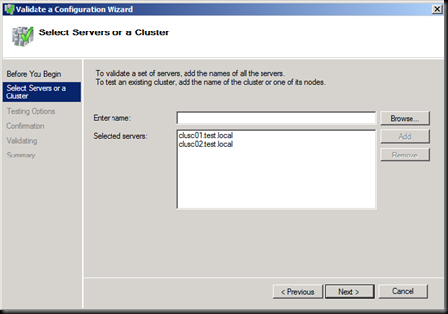](http://blogs.technet.com/blogfiles/aralves/WindowsLiveWriter/BuildingaFailoverClusterwithServerCorePa_DE86/image_4.png)

Run the tests needed for support and to know if the cluster config is correct.

[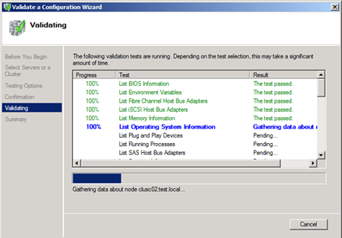](http://blogs.technet.com/blogfiles/aralves/WindowsLiveWriter/BuildingaFailoverClusterwithServerCorePa_DE86/image_10.png)

After all tests have completed you will be able to review the report by clicking onto the report button or if you want to open it afterwards we store all reports in the following directory: "c:\windows\cluster\reports"

[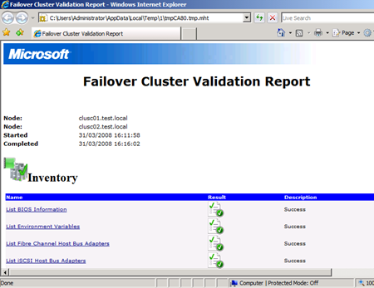](http://blogs.technet.com/blogfiles/aralves/WindowsLiveWriter/BuildingaFailoverClusterwithServerCorePa_DE86/image_12.png)

If the validation tool completes successfully then you can go on with the creation of the cluster. Let's assume everything is fine and perform the actual cluster creation wizard.

[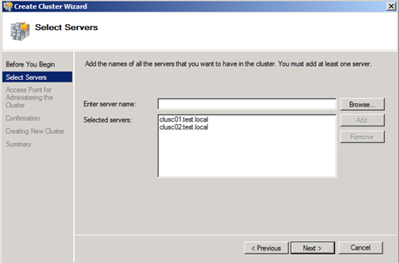](http://blogs.technet.com/blogfiles/aralves/WindowsLiveWriter/BuildingaFailoverClusterwithServerCorePa_DE86/image_14.png)

Fill in all nodes that will be part of this cluster, this is a huge difference comparing to Windows Server 2003 clustering because now the setup wizard is going to configure all nodes at once.

[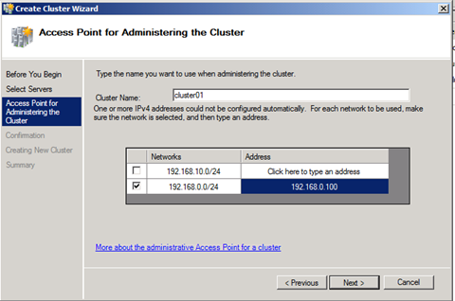](http://blogs.technet.com/blogfiles/aralves/WindowsLiveWriter/BuildingaFailoverClusterwithServerCorePa_DE86/image_18.png)

Give your cluster a name and IP Address in my case I only selected the 192.168.0.0/24 network because that's my public LAN and the second network is only used for heartbeat configuration.

After this step the setup tool is going to create the cluster and making configuration changes on both server core nodes to form a cluster.

[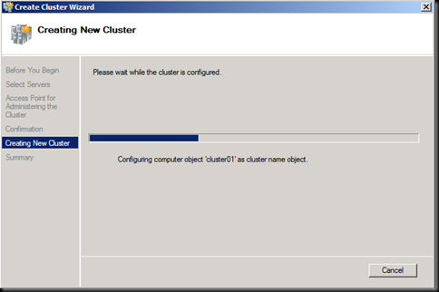](http://blogs.technet.com/blogfiles/aralves/WindowsLiveWriter/BuildingaFailoverClusterwithServerCorePa_DE86/image_20.png)

The cluster is now ready.

[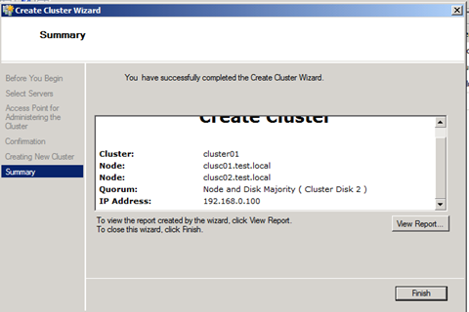](http://blogs.technet.com/blogfiles/aralves/WindowsLiveWriter/BuildingaFailoverClusterwithServerCorePa_DE86/image_22.png)

The next step you need to perform is that the correct Witness disk has been used in my configuration it was not the case and I had to change Witness disk config.

You can do that as follows:

In the action pane click on more action and then select the "Configure Cluster Quorum Settings" as can be seen in the picture below.

[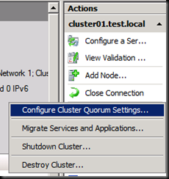](http://blogs.technet.com/blogfiles/aralves/WindowsLiveWriter/BuildingaFailoverClusterwithServerCorePa_DE86/image_24.png)

In the following Wizard you are able to change the Quorum configuration model or change the details of the current Quorum.

[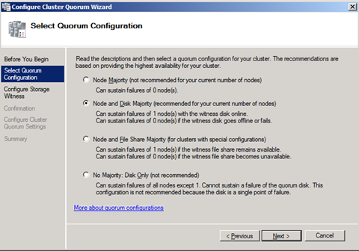](http://blogs.technet.com/blogfiles/aralves/WindowsLiveWriter/BuildingaFailoverClusterwithServerCorePa_DE86/image_26.png)

In my case I just clicked on next and in the screen that follows you will be able to change the disk configuration of the Witness disk.   
  
[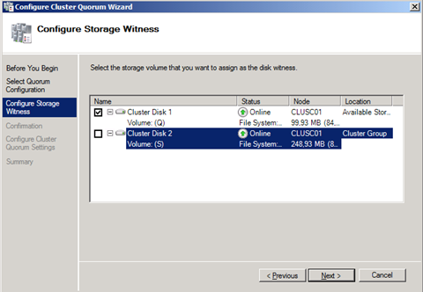](http://blogs.technet.com/blogfiles/aralves/WindowsLiveWriter/BuildingaFailoverClusterwithServerCorePa_DE86/image_28.png)

That is what I've done and now my cluster is up and running and I can start clustering Services or Applications